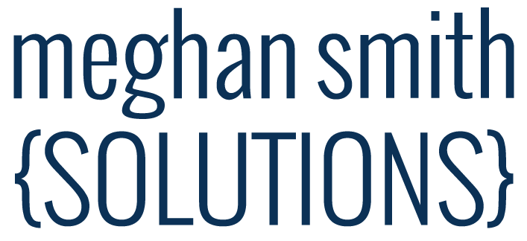

June 2018
Discussed:
- Traffic Report & expected results. Moving to quarterly, so the next one will be in September covering June, July, & August
- Website Text: not changing Cyber Security text at this time. Some things are undecided in that business direction, so we are leaving it as is
- Website header images: adjusting in July (quarterly)
- Search Results/Indexing – Meghan requested the old ‘contact’ page be removed from search engine results
- 404 Page – nice to have one with your branding and navigation as a courtesy
- LinkedIn Page – adjustments desired, path forward
- Ongoing updates: We will meet monthly and review the website traffic quarterly. We’ll plan on doing 1-2 hours/month to keep the web presence fresh, billing as we go for hours worked. The discounted rate of $60/hour is locked in for all work performed through the end of June 2019.
Action Items:

- LinkedIn Changes - we will (assigned to, dependencies/notes)
  - Get Control of the Business Page (Meghan initiated, Chris is following up)
  - Update the Logo (Meghan, pending 1)
  - Update the text to line up with the website (Meghan, pending 1)
  - Update the header image (Meghan, pending 1)
- 404 Page – create a 404 page with branding & navigation in case people end up at the wrong place (Meghan, no rush)

